Start using GIT for version control –

Steps to configure git on local machine:

1. Create folder-

C:\repo\

1. Right-click and select – Git Bash here-

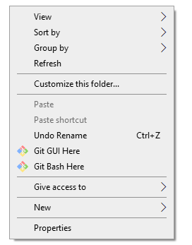

1. Clone git repository-

git clone [git@github.com:pramas-repo/pramas.git](mailto:git@github.com:pramas-repo/pramas.git)

-For error regarding permissions – need to generate and upload sshkey

New development:

1. Navigate to C:\repo\ - Open GIT Bash
2. You should see current folder: /c/repo/pramas (master)

This your local master branch

1. *Get the latest code from master branch every time you start coding-*

git fetch

git pull origin master

1. Create new branch for new development task-

git checkout -b PS-1234 (PS-{branch_no.})

1. Save changes to this branch-

In folder explorer–

Copy and replace the file that is changed/Add new file to the directory

In GIT Bash-

git add .

git commit -m “PS-1234: *Comment*”

git push origin PS-1234

The changes are now pushed to branch PS-1234.